00:23
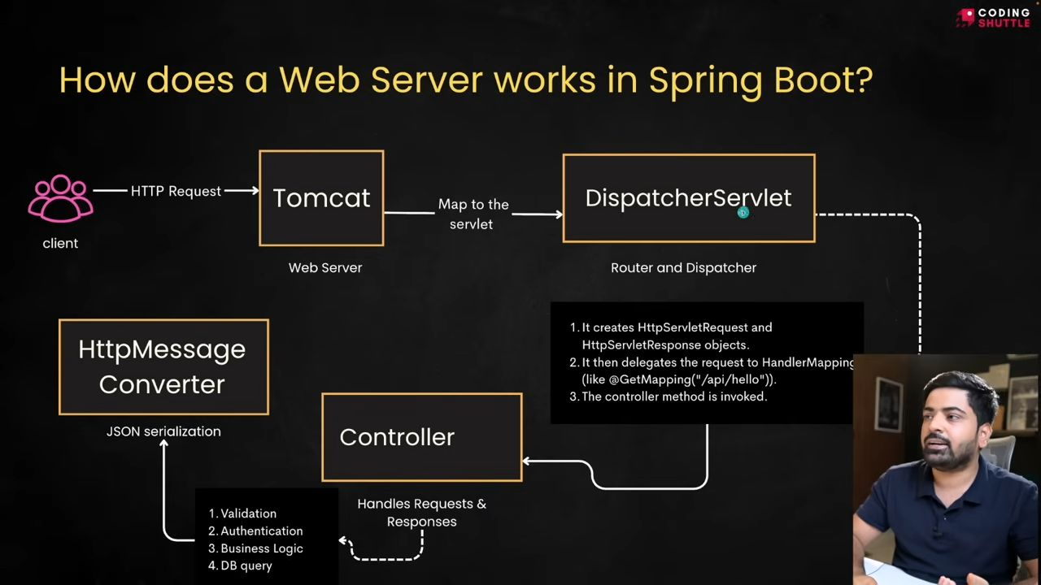
02:41
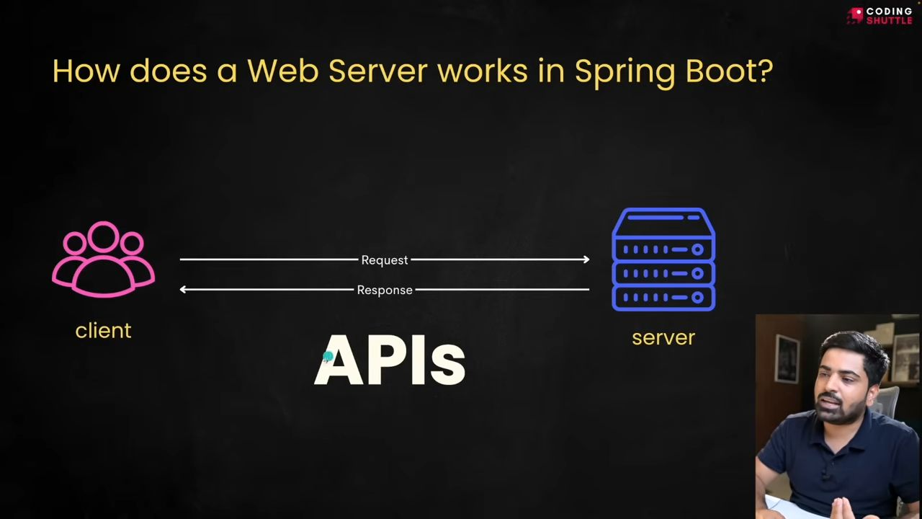
04:17
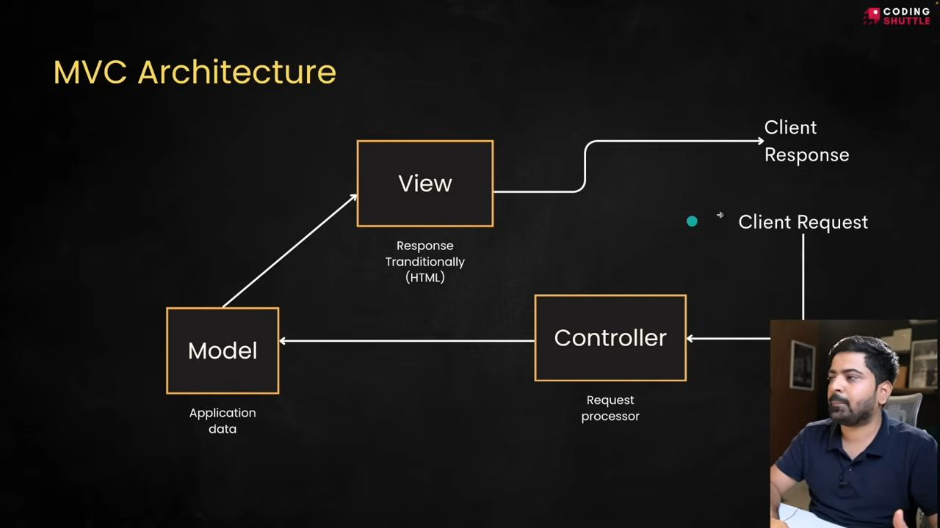
05:31
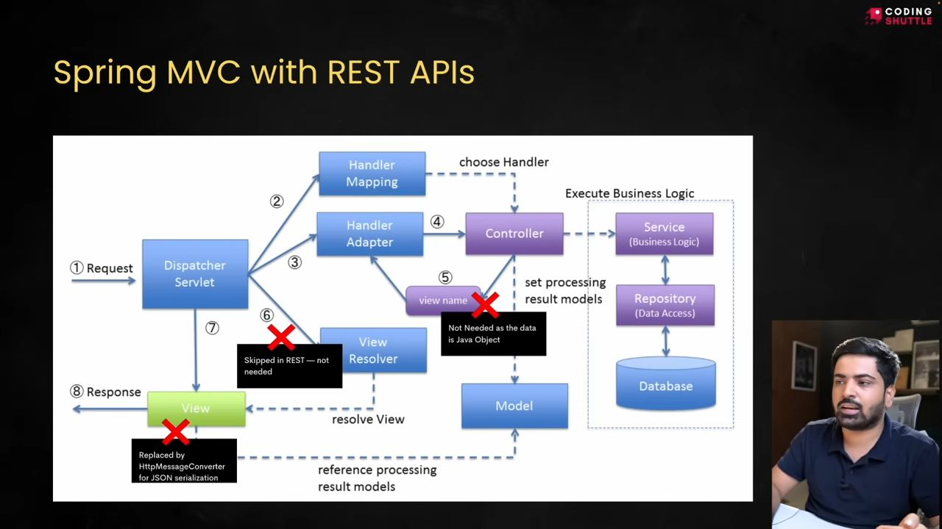
05:35
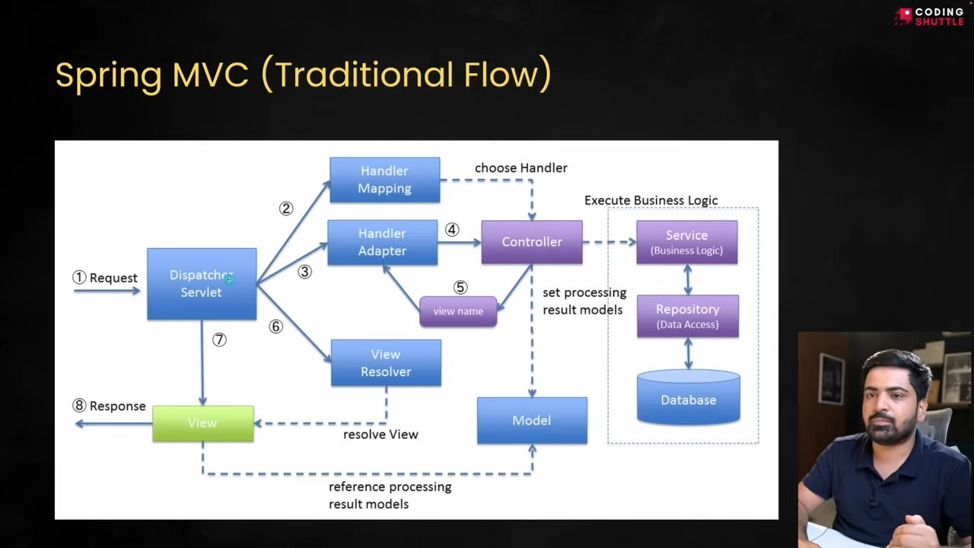
View replace ho gya hai, as now we give JSON as a response, which can be done by the Java library named Jackson.
12:28
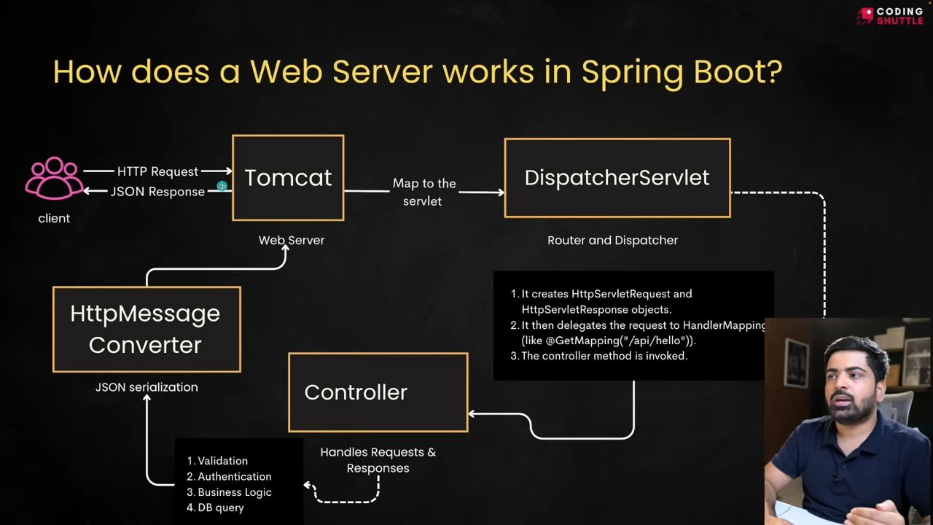
Three-Layered Architecture
20:11
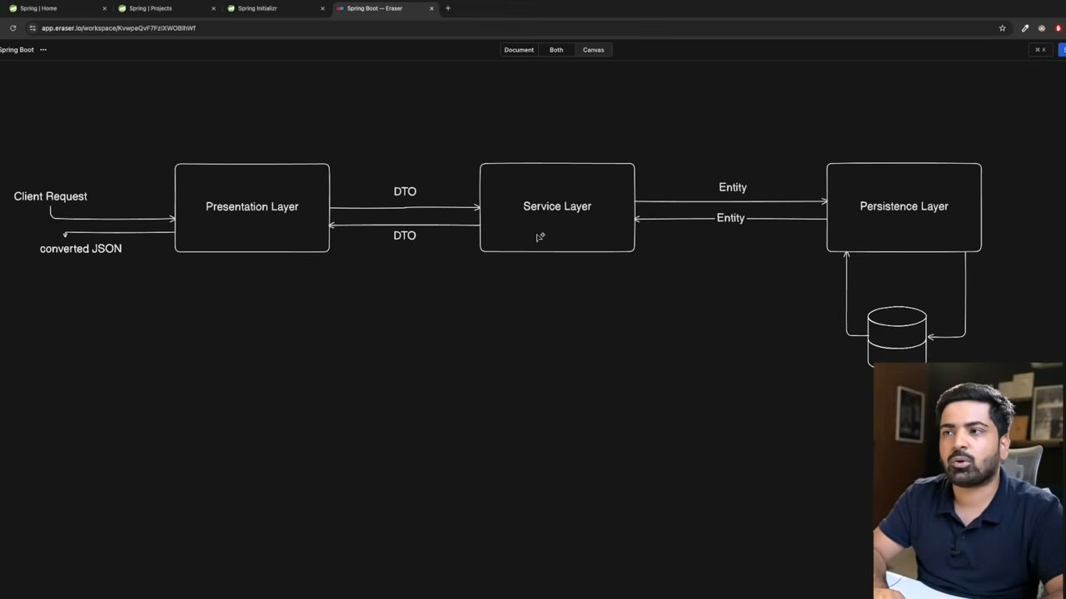
@RestController = @Controller + @ResponseBody
JSP k through HTML return krna hota tha that time we use @Controller and @ResponseBody
Here, the response body gives you a view when you display a web page, like earlier, when you display JSP pages.
But now we use @RestController as it give JSON as a response.
22:55
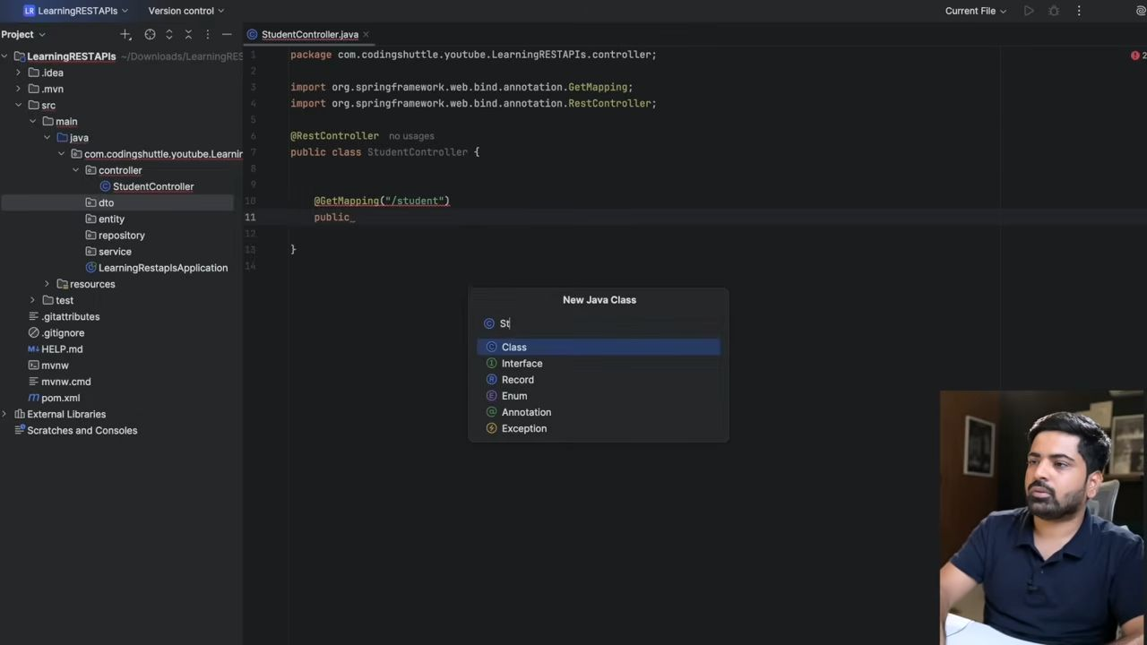
Yaha pe muje Student object chahye toh ya toh mai ek student entity banu ya fir mai ek DTO bana lo.
24:33
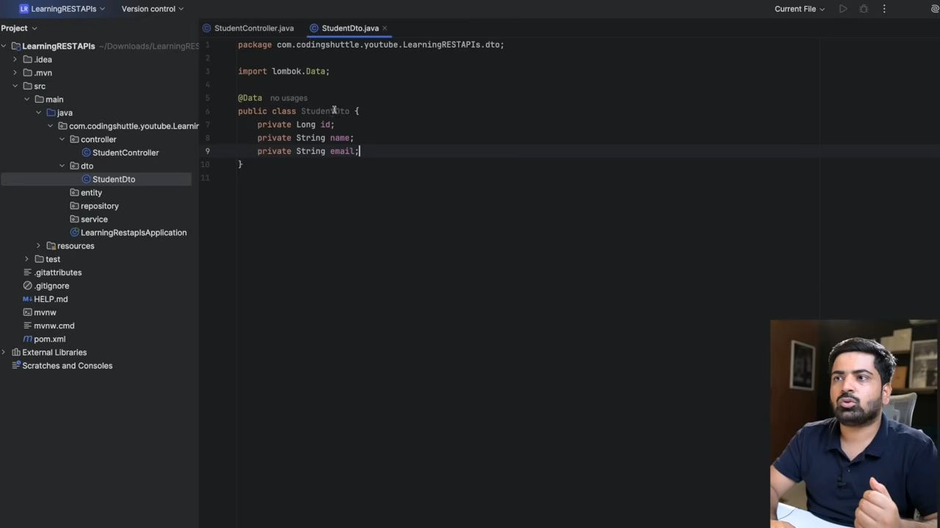
Ye jo "@Data annotation" likha hai humne, ye basically replace karega uss saare code ko, which includes constructor, no-argument constructor, getters, and setters.
Jab iski class file banegi, usme milega humne ye sab constructor getter and setters.
@AllArgsConstructor will create an all-argument constructor for me automatically.
26:42
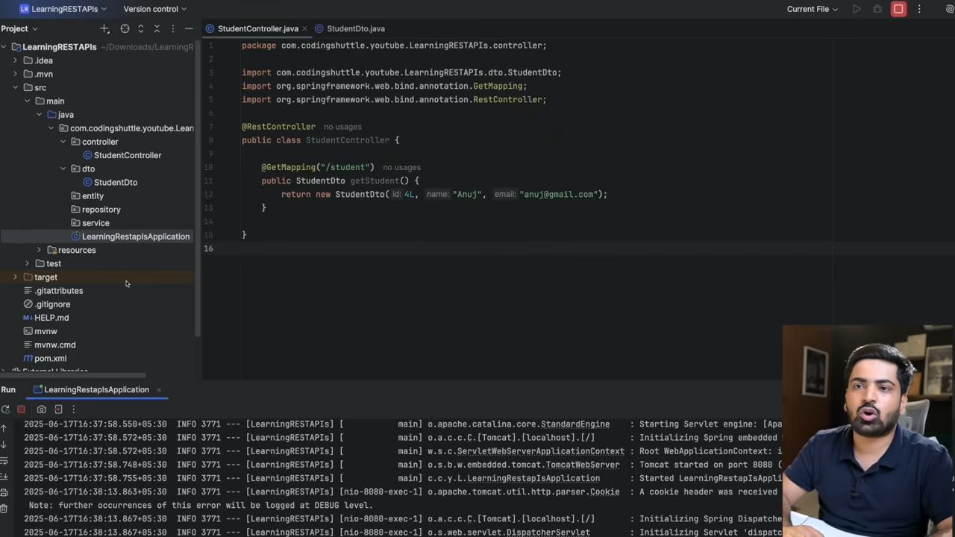
26:20
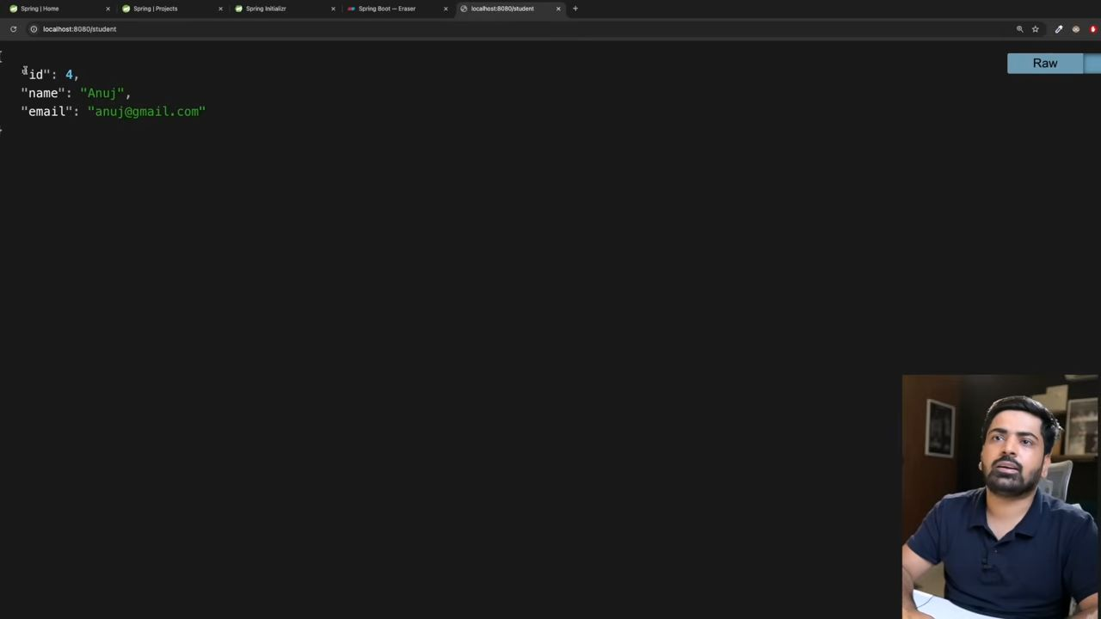
30:07
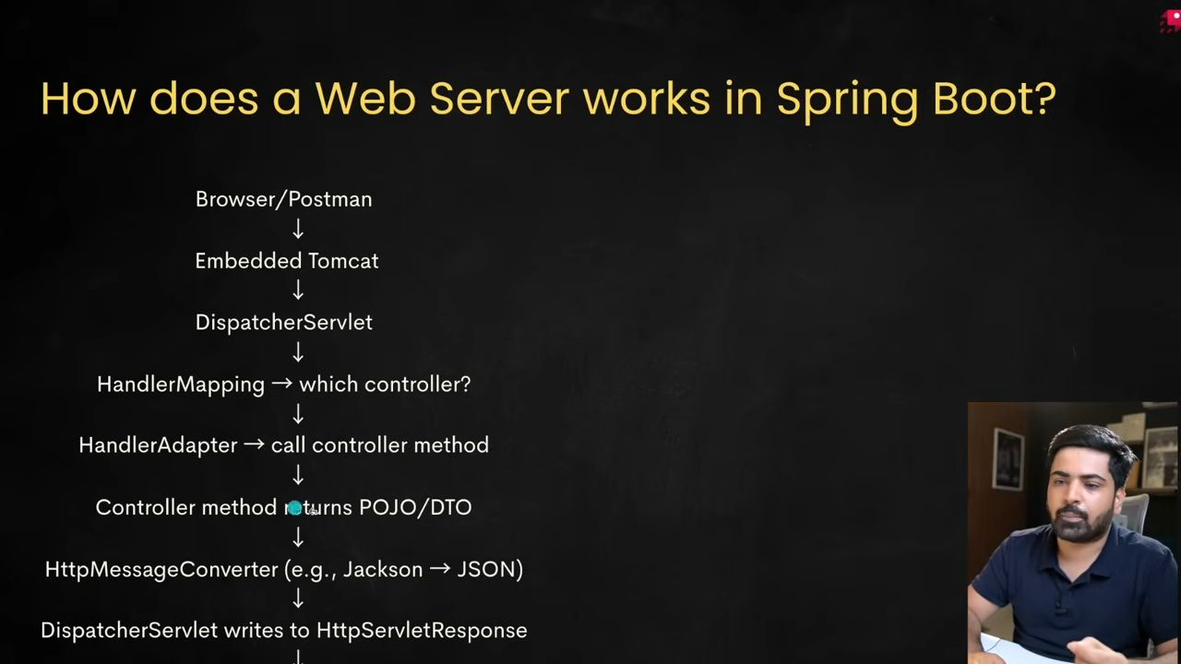
57:23
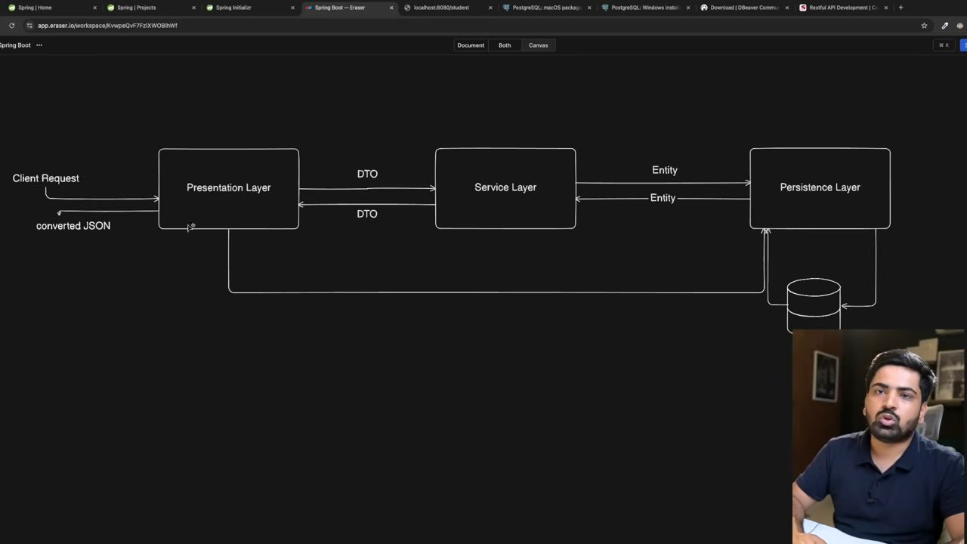
Controller->service->repository
DTO का मतलब होता है Data Transfer Object, जो कि एक ऐसा object होता है जो data को एक layer से दूसरी layer तक transfer करने के काम आता है। Spring Boot में हम generally कंट्रोलर लेवल पर DTO का use करते हैं, ताकि हम API को एक clean और secure response दे सकें।
तो जो controller होता है, वो आमतौर पर DTO return करता है, ताकि client को सिर्फ वही data मिले जो उसे चाहिए और internal implementation छुपी रहे। जब हम service layer से repository layer को call करते हैं, तो हम entity use करते हैं, क्योंकि repository direct database से काम करती है। और service layer में हम entity को लेके काम करते हैं और फिर उसको DTO में convert करके controller को देते हैं। तो basically pattern ऐसा होता है कि repository से entity आती है, service उसे DTO में convert करके controller को देती है।
Perfect! Let’s see how to use ModelMapper to automatically convert Entity → DTO in Spring Boot. This is cleaner for bigger projects.

1. Add ModelMapper dependency
If you are using Maven, add this in pom.xml:
<dependency>
<groupId>org.modelmapper</groupId>
<artifactId>modelmapper</artifactId>
<version>3.1.1</version>
</dependency>

2. Configure ModelMapper Bean
Create a configuration class:
import org.modelmapper.ModelMapper;
import org.springframework.context.annotation.Bean;
import org.springframework.context.annotation.Configuration;
@Configuration
public class AppConfig {
@Bean public ModelMapper modelMapper() { return new ModelMapper(); }
}

3. Entity Class
Same as before:
import jakarta.persistence.Entity;
import jakarta.persistence.GeneratedValue;
import jakarta.persistence.GenerationType;
import jakarta.persistence.Id;
@Entity
public class User {
@Id
@GeneratedValue(strategy = GenerationType.IDENTITY)
private Long id;
private String name;
private String email;
// Getters and Setters
}

4. DTO Class
Same as before:
public class UserDTO {
private String name;
private String email;
// Getters and Setters
}

5. Service Class with ModelMapper
import org.modelmapper.ModelMapper;
import org.springframework.stereotype.Service;
import java.util.List;
import java.util.stream.Collectors;
@Service
public class UserService {
private final UserRepository userRepository; private final ModelMapper modelMapper; public UserService(UserRepository userRepository, ModelMapper modelMapper) { this.userRepository = userRepository; this.modelMapper = modelMapper; } public List<UserDTO> getAllUsers() { return userRepository.findAll() .stream() .map(user -> modelMapper.map(user, UserDTO.class)) .collect(Collectors.toList()); }
}

6. Controller Class
No change here:
import org.springframework.web.bind.annotation.GetMapping;
import org.springframework.web.bind.annotation.RestController;
import java.util.List;
@RestController
public class UserController {
private final UserService userService; public UserController(UserService userService) { this.userService = userService; } @GetMapping("/users") public List<UserDTO> getUsers() { return userService.getAllUsers(); }
}
✅ Why ModelMapper is useful:
- You don’t have to manually write new UserDTO(user.getName(), user.getEmail()) every time.
- Supports nested objects, collections, and custom mappings.
- Makes code cleaner and easier to maintain for large projects.
01:01:43
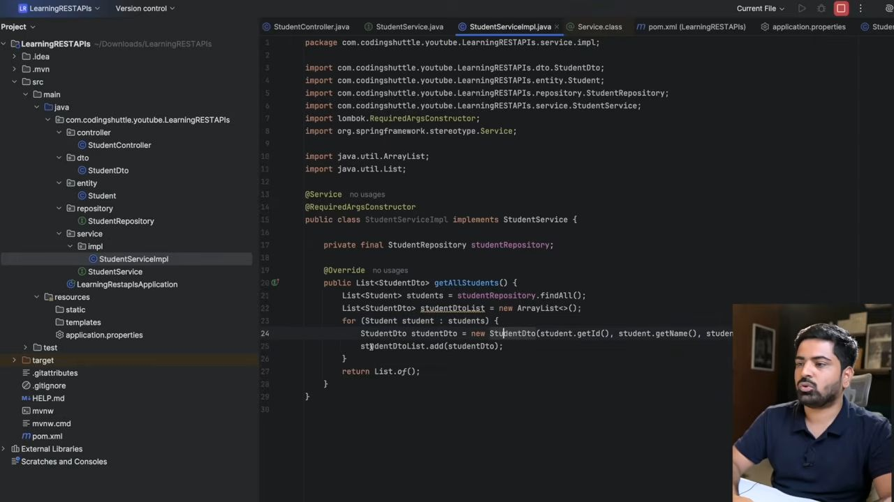
Stream ki help se bhi kr skte hai and for loop se bhi and best hota hai model mapper k through krna.
01:06:35
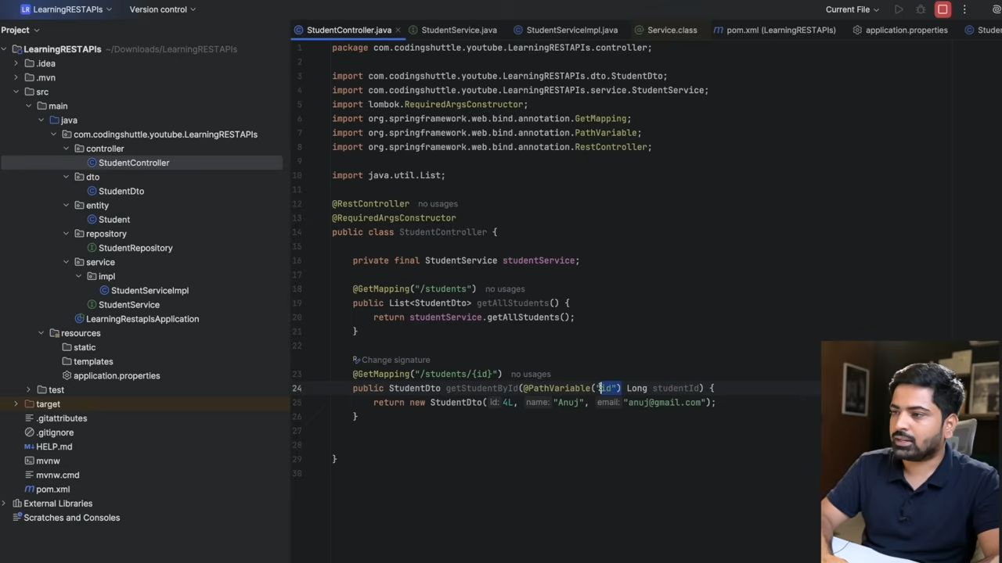
Yaha pe jo id aari hai link mai, wo he naam path variable mai bhi use krna hai but in case agar mai dusra naam likhna chahta hu toh muje @PathVariable("id") Long studentId ese likhna padega; else @PathVariable Long id krna pdta
01:20:05
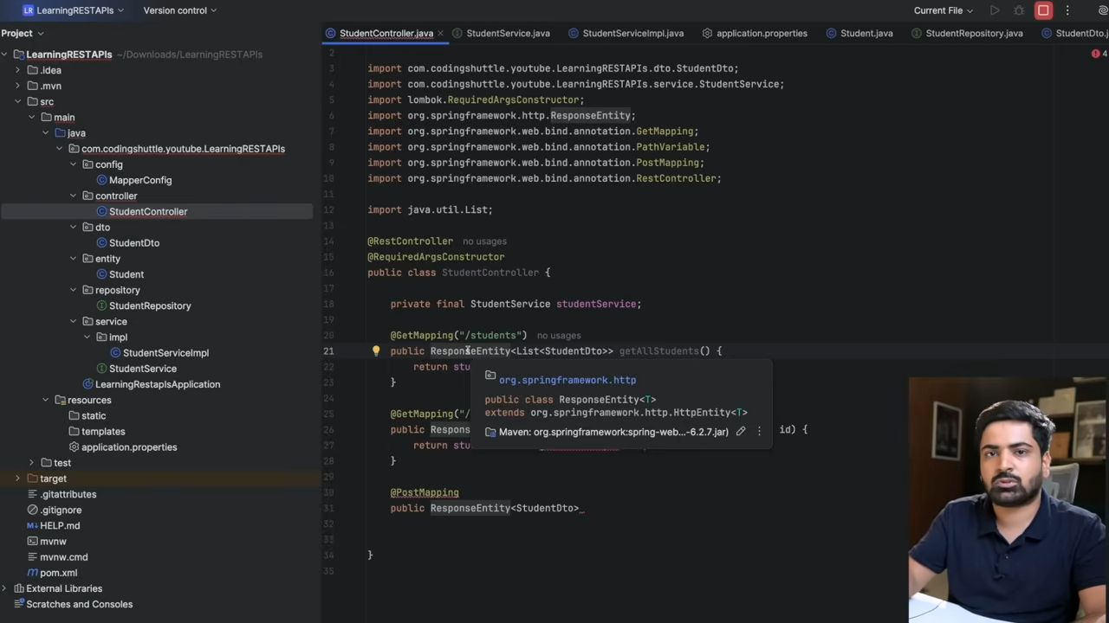
Now we will use response entity to return so that we can also give the status code.
01:23:30
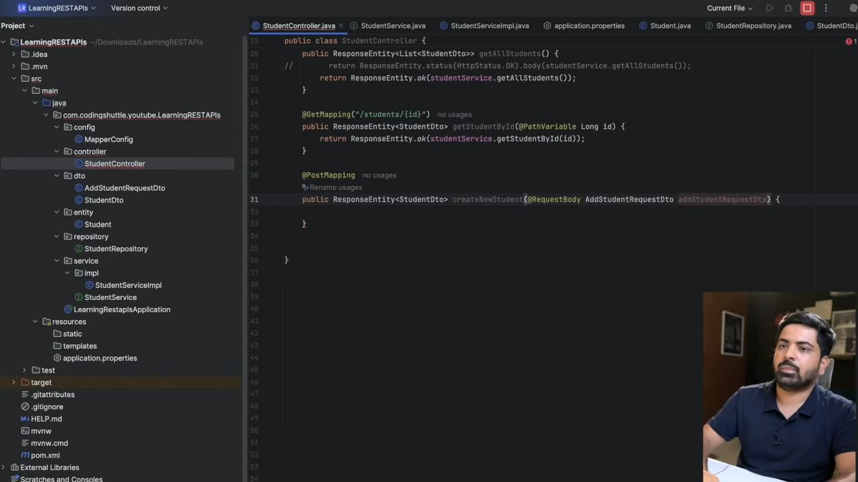
Muje add krte time id nhi chahye islye mai ek naya dto bana lunga.
01:27:33
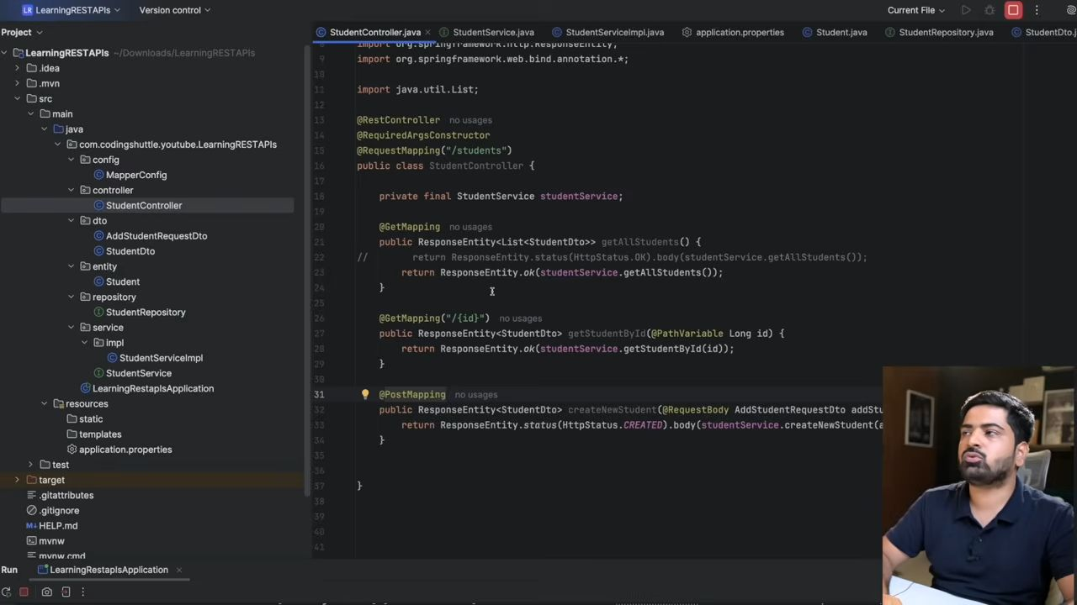
PUT use for Full object change.
Ex: Modifying student with id 1
PATCH use for partial change.
Ex: Modifying name of the student with id 2
For applying validations like email validation etc you can easily do it by adding a dependency in you pom named as sprin-boot-starter-validation
01:50:18
